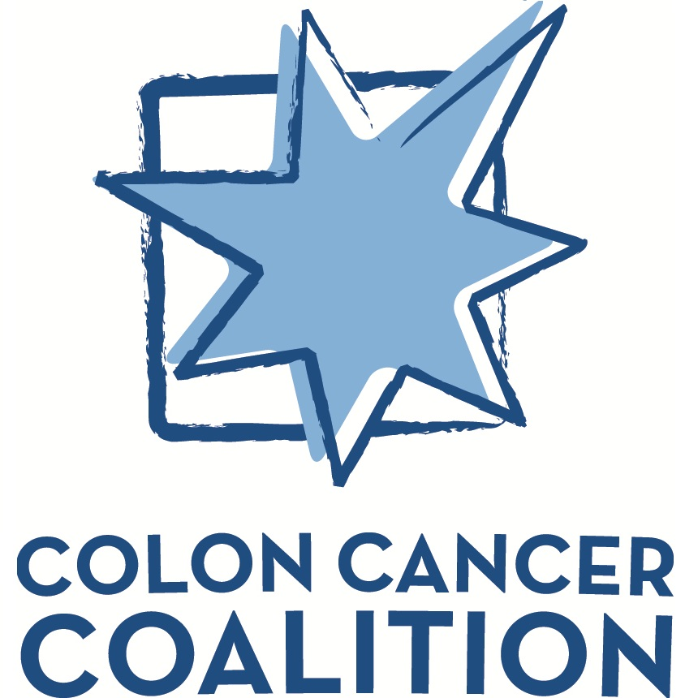

Post Grant Results Summary

Review Submittal Date
Grant Recipient
Recipient Contact Information (name, title, email address, phone)

Get Your Rear in Gear event
Local Event Director(s) Contact Information (name, email address, phone)
Grant Amount $

Summary of Program(s)/Service(s) funded through the grant from the Colon Cancer Coalition:
Please include the following information as it applies to your program:

- How grant dollars were allocated.
- Number of patients served.
- Number of community members impacted by messaging.
- Samples of any printed materials produced to support the program(s).
- How awareness was promoted & number of people impacted.
- How screening rates and behavior changes in your community were impacted by grant money.
- If available: a personal story of family/patient that was affected by grant money (include photo if available).
- We would also like to see any expressions of gratitude that your organization may receive as a result of the services provided by the grant.
- Any other statistics or impact numbers available.
- Share how you partnered with the Colon Cancer Coalition.

(Use additional pages as needed)

Colon Cancer Coalition Post Grant Results Summary - Page 1 of 2
Provide a summary of the partnership provided to the local Colon Cancer Coalition event as laid out in initial application, include links or screenshots as appropriate. (select all that apply)

Publicly acknowledged the grant:
☐ Social media posts and engagement.
☐ Distributed press release (include links or copies of any confirmed coverage).
☐ Blog story or other acknowledgement on our website (include link to page).
☐ Inclusion in newsletter or other communication to our supporters.

Was an active partner in the local event:
☐ Designated someone from your organization to join the event committee.
(Please include name and title: )
☐ Provided connection for with two or three potential vendors or sponsors.
(Please list: )
☐ Formed a team to participate in the event.
☐ Shared event with your sponsors and supporters.
☐ Hosted a table display at the event showcasing how funds were used in the community.
☐ Assisted the local event director with volunteers.
☐ Helped promote the event to local colon cancer survivors and other organizational supporters through the website and/or social media.

Please list other ways your organization was able to be an active partner with the Colon Cancer Coalition this year:

Send completed forms and additional pages or materials to anne@coloncancercoalition.org.
Anne Carlson
Colon Cancer Coalition
5666 Lincoln Dr. #270
Edina, MN 55436
Colon Cancer Coalition Post Grant Results Summary - Page 2 of 2

