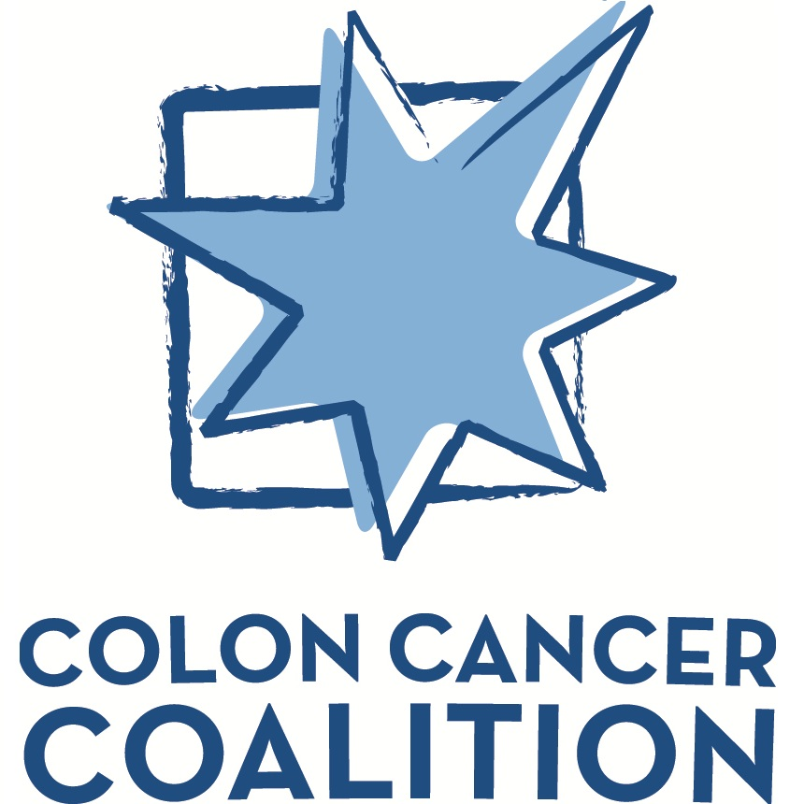

Colon Cancer Coalition
Grant Application and Requirements

Packet Contains
Welcome Letter ● Grant Application ● Template Press Release ● Post Grant Results Summary

Dear Applicant,
The Colon Cancer Coalition is looking for liked-minded partners to grant from funds raised through Get Your Rear in Gear, Tour de Tush, and Caboose Cup events.

To receive funds, organizations are not required to be located in the area where funding is available; however, grant money must be used on programs that will benefit individuals in the local communities where funds were raised. Priority will be given to new programs working to increase screening, patient navigation, or addressing young adult onset colorectal cancer.

Get creative. We are looking for out-of-the-box thinking that will:
- Have a real impact on colorectal cancer screening rates.
- Reach at-risk and underserved communities.
- Target messages to populations at risk for young-onset colorectal cancer.

Contact me at any time with any questions. I look forward to working with your through this process.

Anne Carlson
Executive Director
Colon Cancer Coalition
612-272-0738 / anne@coloncancercoalition.org

Expectations of Applicant
- Publicly acknowledge the grant through a press release, blog and/or web story about the money received from the Colon Cancer Coalition, including check presentations, etc.
- Be an active partner in the local event by joining the committee, assisting with vendors and sponsor contacts, finding volunteers, and promoting the event to your audience and supporters to help us increase awareness and grow participants.
- List Colon Cancer Coalition as a partner on your website including logo.
- Provide organizational logo as well as any images associated with the grant for publication on ColonCancerCoalition.org.
- Attend local event to show impact funds.
- Submit a completed Grant Results Summary (included in packet) following completion of the project or no later than 12 months after receiving grant money, whichever comes first. The grant recipient will need to include specific details on how the grant money was used and the result of the program or related statistics as available (screening rates and behavior changes, etc.).

Provided by the Colon Cancer Coalition
- Support and guidance to both grant applicants and local event directors through the applicant process.
- Timely feedback (questions/clarifications for the applicant, approval, etc.).
- Payment of grant within one month of approval.
- Promotion of grant recipient through coloncancercoaltion.org and other appropriate avenues (social media, etc.).

Important Information Regarding Grant Money:
- Grant money cannot be used for event sponsorships.
- Grant money cannot be used to pay salaries of grantees.
- Grant money cannot be used for direct marketing/advertising for Get Your Rear in Gear events.
- Grant money use must align with the mission of the Colon Cancer Coalition.
- Grant money will be sent directly to grant organization.
Colon Cancer Coalition Mission Statement
Empower local communities to promote prevention and early detection of colon cancer and to provide support to those affected.

Grant Application

Application Date
Get Your Rear in Gear Event
Local Event Director(s) Contact Information (name, email address, phone)

Grant Applicant (organization name)
Contact Information (name, title, email address, phone):

Amount of Money Requested $
Description of Organization and Specific Project to be Funded
Summary of the organization and details about the project. Attach supporting documentation if necessary.

Proposed Use of Granted Funds
Specific use of the funds, i.e.: printing of awareness related materials, fund screening program preps, etc. Include locations and names of outside vendors or providers as well as contact information for persons at these locations. Attach additional pages as necessary. Application must include a line item budget for the funded program.

Colon Cancer Coalition Grant Application - Page 1 of 2
Successful applicants will be expected to play an active role in the Colon Cancer Coalition event in your area. Please select all ways your organization will be able to support and promote your partnership with the Colon Cancer Coalition. (select all that apply)

Publicly acknowledge the grant through:
☐ Social media posts and engagement
(Find us on Twitter at @gyrig, Instagram at @gyrig04, or search “Colon Cancer Coalition” to find our national page and “Get Your Rear in Gear” to find local event pages on Facebook.)
☐ Press release from your organization (sample included in packet)
☐ Blog story or other acknowledgement on your website
☐ Inclusion in newsletter or other communication to your supporters (electronic or traditionally distributed)

Be an active partner in the local event through:
☐ Designating someone from your organization to join the event committee
☐ Connect us with two or three potential vendors or sponsors
☐ Forming a team to participate in the event
☐ Share local Colon Cancer Coalition event with your sponsors and supporters on your website and through social media
☐ Having a table display at the event including showcasing how the funds were used in the community
☐ Assist the local event director and find 5-10 packet pick-up and/or race day volunteers (more is better!)
☐ Help promote the event to colon cancer survivors in your community

Please list other ideas and opportunities for partnership within your organization:

Checks should be made out to: EIN Number:
And sent to: Attn:
Address:
City, St., Zip:
Send completed forms to anne@coloncancercoalition.org or mail to:
Anne Carlson
Colon Cancer Coalition
5666 Lincoln Dr. #270
Edina, MN 55436
Colon Cancer Coalition Grant Application - Page 2 of 2
Delete this text box and copy release to your organization’s letterhead.

After receiving a grant from the Colon Cancer Coalition, please distribute a press release acknowledging the gift to local media contacts. Good outreach points for these releases are the business and healthcare press, and media partners from local events.
You are welcome to use this template or write your own release. In either situation and before distribution, please forward a copy of the release to erin@coloncancercoalition.org for review. Review and approval or comments will be provided within 48 hours. Business days.
The release will also be used as material for the Colon Cancer Coalition’s blog.
Get Your Rear in Gear is used for ease, you may need to replace with Tour de Tush or Caboose Cup depending on the origin of funds for your organization.

FOR IMMEDIATE RELEASE PRESS CONTACT
(Insert name and phone number organization media contact)

Funds raised at Get Your Rear in Gear - (City)
help (organization) fund colon cancer
(education/screening/awareness/support) program

(Event City, St., Date) --- The Colon Cancer Coalition is awarding (organization) with a grant for (program). The money for this grant comes from funds that were raised during the (year) Get Your Rear in Gear – (City) held in (month).

(Brief description of funded program, who will benefit and how the program fits the Colon Cancer Coalition’s mission of screening, awareness, and/or support)

(Quote from local event director about why this event is personally important)

(Quote from benefiting organization about how the funds will impact the local community)

(Quote from Colon Cancer Coalition about how this fits with the broader mission of the CCC)

(If applicable:) A check presentation ceremony will be held on (date) at (location). (Local or national Get Your Rear in Gear - name) representative will be on hand to present a check to the (executive director or other appropriate individual) at the (details). (Please take photographs at this presentation event to post on the Colon Cancer Coalition blog, etc. Forward photos from the presentation to erin@coloncancercoalition.org within 24 hours of ceremony, as well as links to any media coverage from the presentation.)

Registration for 201x Get Your Rear in Gear – (City) on (day, date) is now open. Please visit coloncancercoalition.org/(city) for more information or to be a part of the event.

# # #

Include org’s Boilerplate

About the Colon Cancer Coalition
The Colon Cancer Coalition is a non-profit organization based in Minneapolis, Minn. dedicated to encouraging screening and raising awareness of colon cancer. The organization’s signature Get Your Rear in Gear® and Tour de Tush® event series are volunteer-driven in communities throughout the United States. Since 2004, over $5 million dollars have been granted by the Colon Cancer Coalition to build and sustain programs that promote early prevention, screening, and patient support services for this disease. By making the words colon, colorectal and colonoscopy a part of the everyday language, we believe we can overcome the fear and decrease deaths from this largely preventable cancer. For more information visit ColonCancerCoalition.org.

Post Grant Results Summary

Review Submittal Date
Grant Recipient
Recipient Contact Information (name, title, email address, phone)

Get Your Rear in Gear event
Local Event Director(s) Contact Information (name, email address, phone)
Grant Amount $

Summary of Program(s)/Service(s) funded through the grant from the Colon Cancer Coalition:
Please include the following information as it applies to your program:

- How grant dollars were allocated.
- Number of patients served.
- Number of community members impacted by messaging.
- Samples of any printed materials produced to support the program(s).
- How awareness was promoted & number of people impacted.
- How screening rates and behavior changes in your community were impacted by grant money.
- If available: a personal story of family/patient that was affected by grant money (include photo if available).
- We would also like to see any expressions of gratitude that your organization may receive as a result of the services provided by the grant.
- Any other statistics or impact numbers available.
- Share how you partnered with the Colon Cancer Coalition.

(Use additional pages as needed)

Colon Cancer Coalition Post Grant Results Summary - Page 1 of 2
Provide a summary of the partnership provided to the local Colon Cancer Coalition event as laid out in initial application, include links or screenshots as appropriate. (select all that apply)

Publicly acknowledged the grant:
☐ Social media posts and engagement.
☐ Distributed press release (include links or copies of any confirmed coverage).
☐ Blog story or other acknowledgement on our website (include link to page).
☐ Inclusion in newsletter or other communication to our supporters.

Was an active partner in the local event:
☐ Designated someone from your organization to join the event committee.
(Please include name and title: )
☐ Provided connection for with two or three potential vendors or sponsors.
(Please list: )
☐ Formed a team to participate in the event.
☐ Shared event with your sponsors and supporters.
☐ Hosted a table display at the event showcasing how funds were used in the community.
☐ Assisted the local event director with volunteers.
☐ Helped promote the event to local colon cancer survivors and other organizational supporters through the website and/or social media.

Please list other ways your organization was able to be an active partner with the Colon Cancer Coalition this year:

Send completed forms and additional pages or materials to anne@coloncancercoalition.org.
Anne Carlson
Colon Cancer Coalition
5666 Lincoln Dr. #270
Edina, MN 55436
Colon Cancer Coalition Post Grant Results Summary - Page 2 of 2

